CSE446/598 Assignment2
Readme
Shihuan Shao

- Download the zipped package REST-Greeting-sshao1 and unzip.

- Open NetBeans IDE 7.2.1. Click File -> Open Project. Go to the download folder and open the project Rest-Greeting-sshao1.
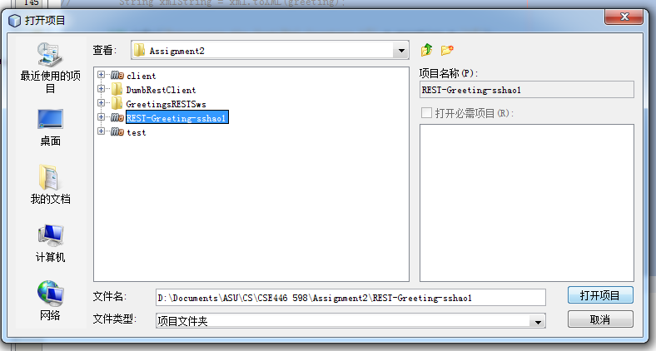

3. Right click on the icon Rest-Greeting-sshao1, select Run. The NetBeans I downloaded is English version, but maybe because of the environment of my system, it automatically changes to Chinese version. However, the position of corresponding items are the same with the English version.
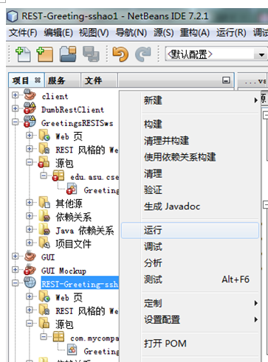

If you are asked to choose a server, choose GlassFish Server 3.1.2:
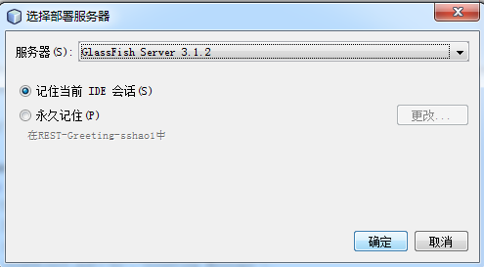

4. The output panel will be open and show following contents:

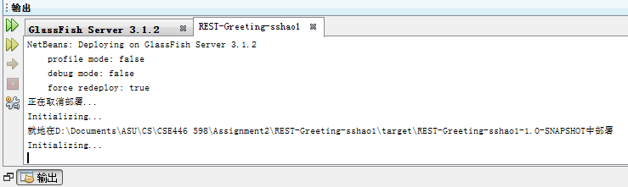

A JSP page is also automatically opened and show “Hello World!”:
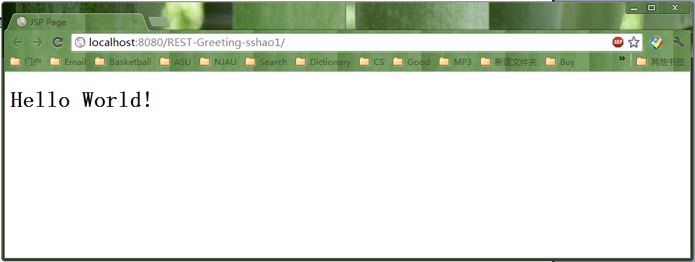
Now the service is deployed on GlassFish Server 3.1.2.

5. Click Restful Web Services -> GreetingResource [greeting] -> HTTP methods

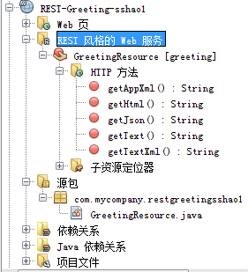

6. Right-click on method getAppXml():String, select Test Resource Uri:
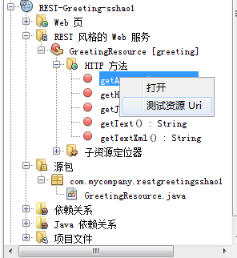

The following page (application/xml) will be showed in the browser:
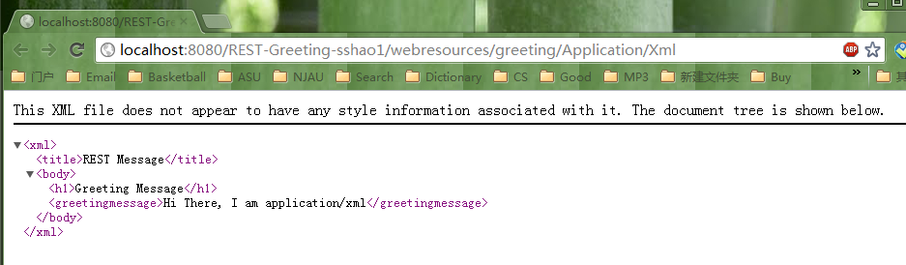

Similarly, the use can check the other four resources:
text/html:
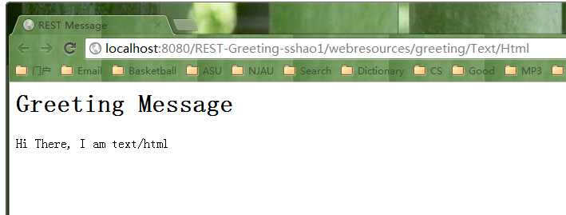

application/json:
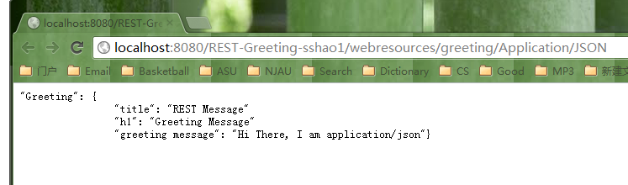

application/plain:
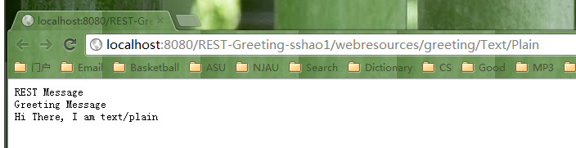

text/xml:
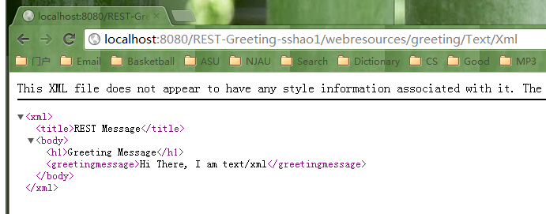

7. An alternative way Step 6 is to type the addresses into the browser directly. Pay attention to the uppercase and lower case.

Application/Xml:
http://localhost:8080/REST-Greeting-sshao1/webresources/greeting/Application/Xml

Text/Html:
http://localhost:8080/REST-Greeting-sshao1/webresources/greeting/Text/Html

Application/JSON:
http://localhost:8080/REST-Greeting-sshao1/webresources/greeting/Application/JSON

Text/Plain:
http://localhost:8080/REST-Greeting-sshao1/webresources/greeting/Text/Plain

Text/Xml:
http://localhost:8080/REST-Greeting-sshao1/webresources/greeting/Text/Xml

-End-

